1. Introduction 3
1.1 Project Background and Objectives 3
1.2 Scope and Methodology 3
1.3 Healthcare Data Challenges 4
1.4 Databricks Unity Catalog Overview 4
1.5 Report Structure 5
2. Databricks Unity Catalog New Features Deep Dive 6
2.1 Data Discovery Enhancements 6
2.1.1 Feature Overview and Architecture 6
2.1.2 Tagging and Metadata Management 7
2.1.3 Search and Discovery Capabilities 7
2.1.4 Integration with Healthcare Systems 8
2.2 Data Discovery Use Cases in Healthcare 8
2.2.1 Patient Data Management 8
2.2.2 Enhanced Data Discovery Use Cases in Unity Catalog for Healthcare 9
2.2.3 Research Data Accessibility 10
2.3 Practical Implementation 10
2.3.1 Datasets Used 10
2.3.2 Data Ingestion, Table Creation, and Metadata Tagging 16
2.3.3 Metadata Enrichment: Descriptions and Tags 18
2.3.4 Catalog Hierarchy 19
2.3.5 Data Discovery Demonstration 20
2.4 Advanced Data Lineage Capabilities 26
2.4.1 Feature Overview 26
2.4.2 Lineage Tracking Mechanisms 27
2.4.3 Lineage Tracking Requirements 27
2.5 Ensuring Data Integrity with Unity Catalog 28
2.5.1 Automated Lineage Tracking for patient data 28
2.5.2 Data Quality Validation through Lineage 28
2.5.3 Integration with Healthcare Standards 28
2.6 Compliance and Auditing using Unity Catalog 29
2.6.1 HIPAA Compliance Through Audit Trails 29
2.6.2 Automated Compliance Reporting 29
2.6.3 Risk Assessment and Impact Analysis 29
2.7 Unity Catalog’s Data Lineage Architecture 30
2.8 Implementation Use Cases: Lineage 31
2.8.1 View Table Lineage 31
2.8.2 View Column-Level Lineage 33

1. Introduction

1.1 Project Background and Objectives
Healthcare generates a vast amount of diverse data that requires careful management to benefit all stakeholders involved. Effectively managing medical images, patient records, and clinical research data requires advanced systems and methods. This leads to improved outcomes and enhances research workflows while adhering to relevant regulations.
Currently, many data management techniques in healthcare lack transparency, auditability, and collaboration. This internship project examines how the new features of Databricks Unity Catalog can address these critical issues. With its recent enhancements, Unity Catalog enables healthcare organizations to more effectively find, manage, and utilize their data.
The main goals of this project are to:
- Explore the new features of Unity Catalog and their application in healthcare.
- Identify use cases where these features can provide benefits to the organization.
- Navigate the Databricks environment and outline the step-by-step implementation of the identified use cases.
- Provide firsthand practice with practical applications on the Databricks platform.
- Assess the impact and return on investment for healthcare organizations.

1.2 Scope and Methodology
This report comprehends a detailed study on three new features of Unity Catalog that include Data Discovery, Data Lineage, and Auditing. The approach involves both theoretical research and hands-on implementation of these features in the Databricks environment. It aims to focus on health-related applications of Unity Catalog and how it can be used to improve performance and scalability for large healthcare organizations. Also, the integration of the identified use cases in existing healthcare systems and the evaluation of compliance implications are addressed.
The project follows a planned approach to balance both academic and practical implications of the findings. From exploring trending complications in healthcare data management to their effective solutions supported by the new features of Unity Catalog, this study combines literature review, feature analysis, use case development, and viable implementation.

1.3 Healthcare Data Challenges
While working with the healthcare sector, data comes with a lot of challenges. From data collection to applying machine learning algorithms to extract valuable insights, every step presents its own set of difficulties.
During the data collection process, researchers and healthcare providers gather data from various sources, out of which only a few have governance habits. Capturing data that is clean, accurate, and valuable is a big challenge faced by most organizations. As the volume of data in healthcare is increasing exponentially, it is estimated that the industry accounts for 30% of the world's total data volume. [1] Some providers are still not able to incur the costs and management of on-premises data centers. Along with data collection and storage, another major challenge arises from a lack of data lineage and governance, which sometimes results in inaccurate diagnoses, medical errors, and inappropriate decisions. In healthcare, the quality of data directly impacts the patient’s safety, and it is crucial to implement assurance policies for minimal breakthroughs. Moreover, the diversity of data requires sophisticated cataloging and discovery for easy and less time-consuming accessibility without compromising data security.

1.4 Databricks Unity Catalog Overview
Unity Catalog is a Databricks’ unified governance model for structured and unstructured data, as well as AI. It provides a centralized place for the administrator to manage, secure, and audit data access across the databricks environment. In many organizations, the data isolation boundaries can often lead to siloed environments that can make both governance and collaboration unnecessarily difficult. Unity Catalog provides a solution to this problem by isolating data without compromising governance.

To create a data isolation model using Unity Catalog, it is important to understand the hierarchy it offers. At the top, there is a metastore, which is the top-level container for managing data assets and controlling access permissions for the same. Catalogs are the primary unit of data isolation, residing in the metastore to group schemas having the same access requirements. Inside catalogs, schemas, or databases are defined to provide a structured way to organize data depending on their format. Tables and volumes are the data assets that contain both structured and unstructured data entities.
Unity catalog offers numerous features for data isolation. Some of them are listed below:
- Users can only access data based on the predefined rules and permissions.
- Data can be managed by designated people only. It provides a choice between a centralized governance model and a distributed governance model. In centralized governance, only the owners are administrators of the securable object and can assign or revoke permissions from a group. On the other hand, the owners of a catalog can create and own all the assets and manage governance within that domain in distributed governance. It ensures data access management based on the organization’s needs and requirements.
- Unity Catalog enables physical separation of data in specific storage locations. It allows for configuring storage locations at all three levels- metastore, catalog, and schemas.
- Data access is limited to designated environments in the Unity Catalog. Workspaces are primary data processing environments in Databricks, and to process data, catalogs should be accessible to specified workspaces. Workspace-catalog binding can be used to ensure data access while making sure that isolation is not hindered.
The ability of Unity Catalog to provide all the necessary features required to store, manage, monitor, and analyze data makes it a comprehensive platform for complex data and AI workloads. The core functionalities provide centralized support for healthcare governance requirements with diverse infrastructure.

1.5 Report Structure
This report contains three sections. The first section introduces the new features of Unity Catalog and detailed description of each of them. The second section analyses use cases of the defined features in the healthcare industry. Finally, the last section comprises of step-by-step demonstration of a few use cases on the Databricks platform. Also, it includes business analysis at the organizational level to evaluate expected impacts and challenges while applying these features in real-world adoptions.

2. Databricks Unity Catalog New Features Deep Dive

2.1 Data Discovery Enhancements
Data discovery refers to a process that includes exploring data and analysing it to generate visuals and gain insights for better decision making. It goes beyond simple reports and is used for navigating data visually, leveraging advanced analytics, and enabling better-informed decisions. In a sector like healthcare, where data is fragmented in different systems, there is a growing need for a unified storage so that fetching can be made quicker and less complex. Clinical researchers must collect all types of data, like medical images, health records, and patient illness histories, from different sources. Unity Catalog makes data discovery a much easier process.

2.1.1 Feature Overview and Architecture
Databricks’ Unity Catalog provides an enhanced feature for discovering data by integrating advanced capabilities that represent a fundamental asset for healthcare industries to manage and analyse huge amounts of data optimally. The intelligent discovery mechanisms include machine learning and AI tools, which make it easier to fetch the data. It helps to uncover patterns from patient records to provide them with faster treatments while taking care of the complexity and security of data.
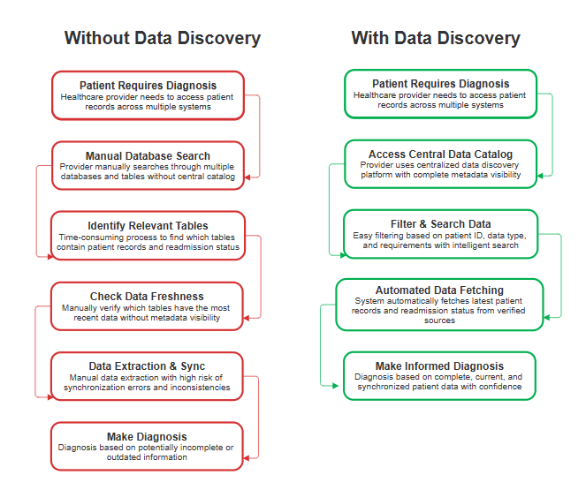
Consider a healthcare provider who needs to access patient records to diagnose a disease across multiple tables and databases. Without the data discovery feature, the provider has no central catalog to access the data. Also, he does not know which tables contain the latest patient records and readmission status. Metadata of the tables will not be visible, which can result in false assumptions and wrong decision-making. These challenges will lead to increased risks, intensive manual work, and unnecessary complications. With the data discovery feature, the user can simply filter or fetch data based on the requirements, without worrying about manual errors and synchronization faults. Enabling data discovery can directly help in improving performance while maintaining informed healthcare innovations.

2.1.2 Tagging and Metadata Management
Data discovery in the Unity Catalog is significantly enhanced through tagging and metadata management. These advanced capabilities are specifically designed to meet the complex data classification needs of the healthcare industry. Traditional tagging systems rely on manual annotations for classification processes. In contrast, Unity Catalog employs an approach that integrates automated cataloging with manual overrides. These components allow organizations to maintain searchability and control over their data within the Databricks environment.
Custom labels or business-relevant tags can be applied to tables to categorize and classify datasets across various domains. It also facilitates the automatic capture of metadata to store important records, such as creation date, schema, ownership, and modification history. Searching and filtering data becomes much simpler with tag-based labelling.
In addition to the powerful features mentioned above, Unity Catalog includes another critical aspect: automated detection of Protected Health Information (PHI) in healthcare data across different formats and schemas. The system employs advanced analysis and algorithms to identify direct identifiers such as patient name, birth date, and address, even if they are enclosed within complex tables. With this, data access can be streamlined to avoid security issues and compliance disputes.
Healthcare organizations can define and assign labels to their data assets that align with their specific operational and monitoring requirements. The system assists hierarchical classification by defining schemas along with their descriptions or identifiable keywords. For example, an organization might define different tags for clinical research data, medical health records, technical reports, etc.

2.1.3 Search and Discovery Capabilities
Unity Catalog’s improved search and discovery functionalities have been considerably built to meet the needs of healthcare organisations. It combines the strength of traditional metadata management with natural language processing to help researchers and clinicians in extracting data and its insights using familiar clinical terminologies rather than complex queries. The NLP models or engines are trained with healthcare-specific vocabularies present related to the data to include relevant terms in future searches as well.
Search results in Unity Catalog cover all important aspects of data rather than restricting to data entities. Each result is enhanced with data lineage information, describing each stage of data transformation. It also contains how many times and by whom this data has been accessed in the past. Preliminary details of data, like how it is collected, stored, and processed, are also available in the search results, which helps to understand the datasets better. Compliance-related metadata, such as sensitivity levels of PHI and access restrictions, are some other components of search results in Unity Catalog.
The Unity catalog introduces collaborative search by tracking frequently searched data assets by the user. By using these former searches, the system identifies patterns and improves search recommendations. Also, the users can give ratings or feedback to the recommendations in the form of descriptive comments to explain how specific datasets were used in a particular search.

2.1.4 Integration with Healthcare Systems
Unity Catalog's discovery features are designed for the complex environments typical in healthcare organizations. Healthcare settings often use many specialized systems, each with its data models, access patterns, and integration needs. To streamline the management of healthcare data, Unity Catalog proves to be a significant model due to its seamless integration with Electronic Medical Record (EMR) systems. This improves the real-time metadata synchronization, access control while maintaining the performance and accuracy of clinical treatments. It facilitates understanding of data for clinicians and analysts without requiring high expertise or system-specific knowledge.
Healthcare data goes beyond EMRs into laboratory and imaging systems. Unity Catalog offers metadata extraction from the Laboratory Information Management Systems (LIMS) and supports indexing based on imaging in Picture Archiving and Communication Systems (PACS).
These integrations ensure that all types of data in healthcare, including structured data, unstructured data, and high-volume laboratory outputs, are governed under a unified management system.

2.2 Data Discovery Use Cases in Healthcare

2.2.1 Patient Data Management
Patient data management is a core component of modern healthcare systems to ensure correct diagnosis, treatment, and compliance throughout the healthcare lifecycle. Collecting data, storing it in a secure database or cloud platforms, defining access controls, and finally analyzing it to extract valuable insights are key aspects of managing patient data to reduce medical errors and enhance operational efficiency in healthcare. Unity catalog’s data discovery feature offers various powerful tools to manage, discover, and govern data across complex healthcare systems. A few of them are listed below:
- Data Cataloging:
It is a process to index and manage the metadata to make datasets easily accessible across an organization. A catalog is a centralized storage for data assets, where each dataset is listed with its details like name, schema, owner, and security level.
Unity Catalog creates a centralized inventory for all the patient data across a healthcare organization, which can automatically discover all patient data sources, capture essential information about each dataset, and provide a unified view of data scattered across multiple applications and departments. It also creates a structured hierarchy for the data to manage access controls according to the authority and permissions.
- Data Tagging and Classification:
With tagging and classification, data sensitivity tags can be applied to patient data to detect PHI (Protected Health Information), PII (Personally Identifiable Information), and extract summaries without revealing individual information. Clinical domain tags can also be applied to detect several types of data, like diagnostic data, treatment data, and research data. It reduces manual effort to identify and classify tables and ensures no compromise in data governance policies.
- Search and Discovery Capabilities:
Unity Catalog supports full-text searches for healthcare professionals across table names, column names, descriptions, or even tags. It allows the administrator to access data through SQL queries along with business vocabulary by standardizing medical terminologies. This feature provides a robust, healthcare-ready search that can be used to utilize data efficiently without requiring deep technical knowledge of complex clinical language.
- Documentation and Metadata Management:
Healthcare data is immensely valuable, but without proper, clear descriptions and clinical context, it is just numbers and records. Unity Catalog delivers rich documentation at various levels to make sure that a person accessing data for the first time faces minimal challenges to understand it properly. Table-level and column-level descriptions can be added to define purpose, source, and access restrictions for every dataset. It helps to improve data quality through better understanding of what, where, and why it is present.

2.2.2 Enhanced Data Discovery Use Cases in Unity Catalog for Healthcare
- Intelligent Patient Cohort Discovery
- Clinical Research Accelerator
- Predictive Data Needs
- Multi-Modal Data Integration

2.2.3 Research Data Accessibility
In traditional data management systems, researchers often spend months or even years collecting and preparing datasets, only to discover that similar work is being duplicated by other researchers at different institutions. This leads to redundant efforts, wasted resources, and delayed insights. With Unity Catalog’s Data Discovery feature, organizations can eliminate this inefficiency by enabling controlled data access based on user roles, positions, and designations. This ensures that researchers can easily discover existing datasets relevant to their work, reducing unnecessary duplication. At the same time, strict access controls maintain data privacy and governance. By facilitating secure data sharing, promoting transparency, and encouraging collaboration, Unity Catalog enhances both productivity and performance across research teams, ultimately accelerating innovation in healthcare.

2.3 Practical Implementation

2.3.1 Datasets Used
To get hands-on experience with Unity Catalog’s data discovery feature and its core functionalities, let us explore the Databricks environment step-by-step.
A catalog named dataDiscovery was created using Databricks Unity Catalog, designed to organize, tag, and manage metadata for diverse healthcare-related datasets.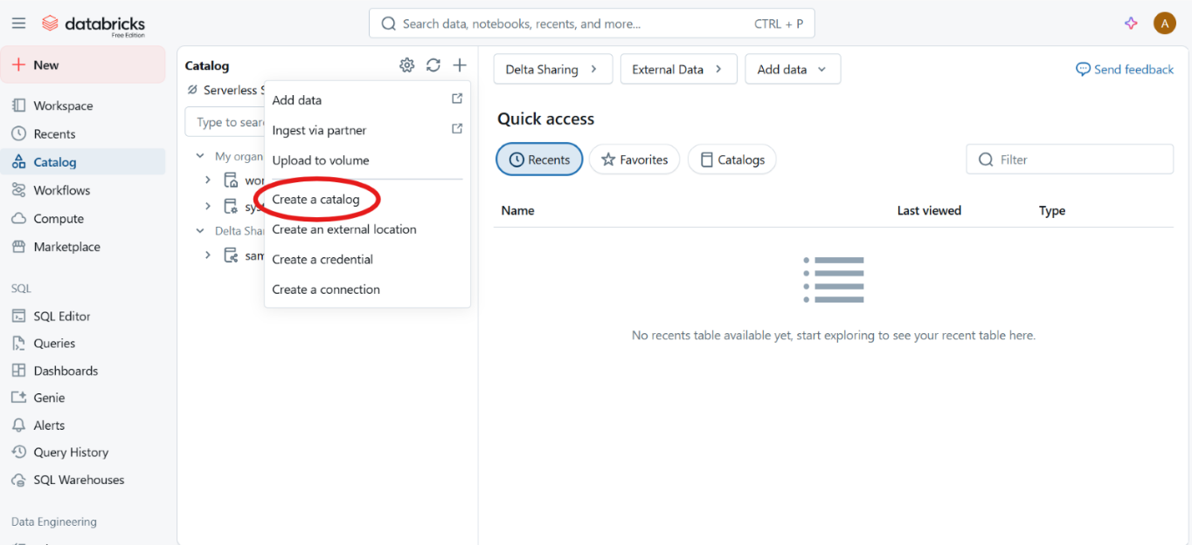
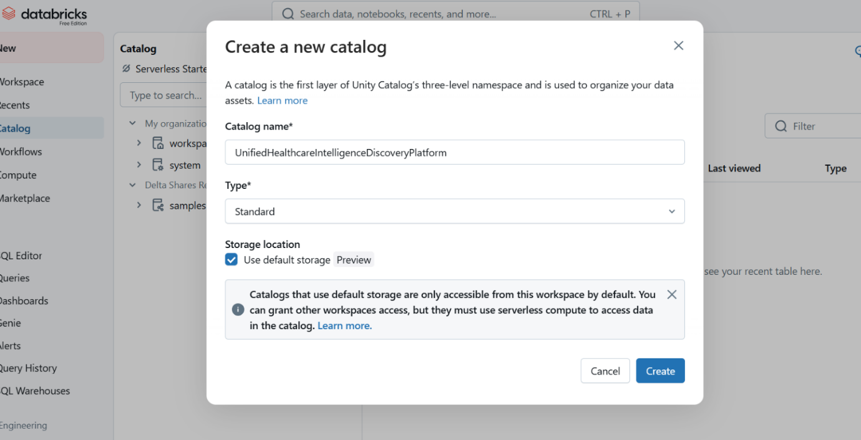

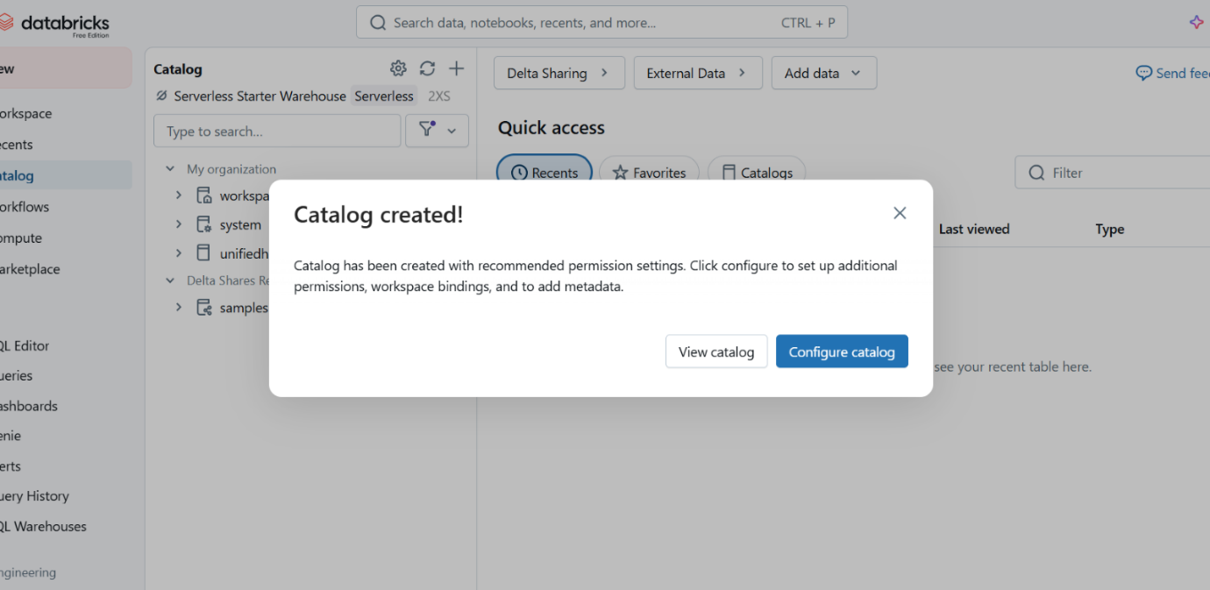
After creating the catalog, Unity Catalog allows the user to configure its access control and metadata manually. Using these features, the admin can define who can access what.
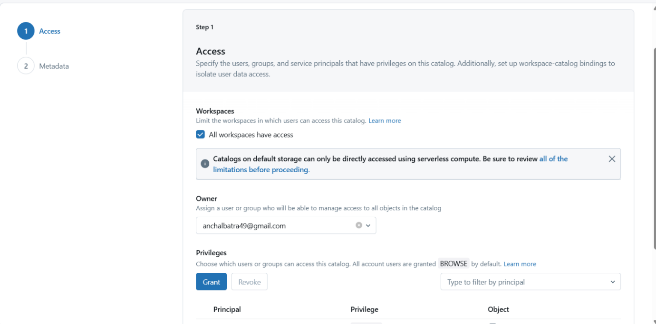
The various privileges like USE CATALOG, USE SCHEMA, EXECUTE, etc can be granted or revoked accordingly depending upon the needs and requirements of the analysis.
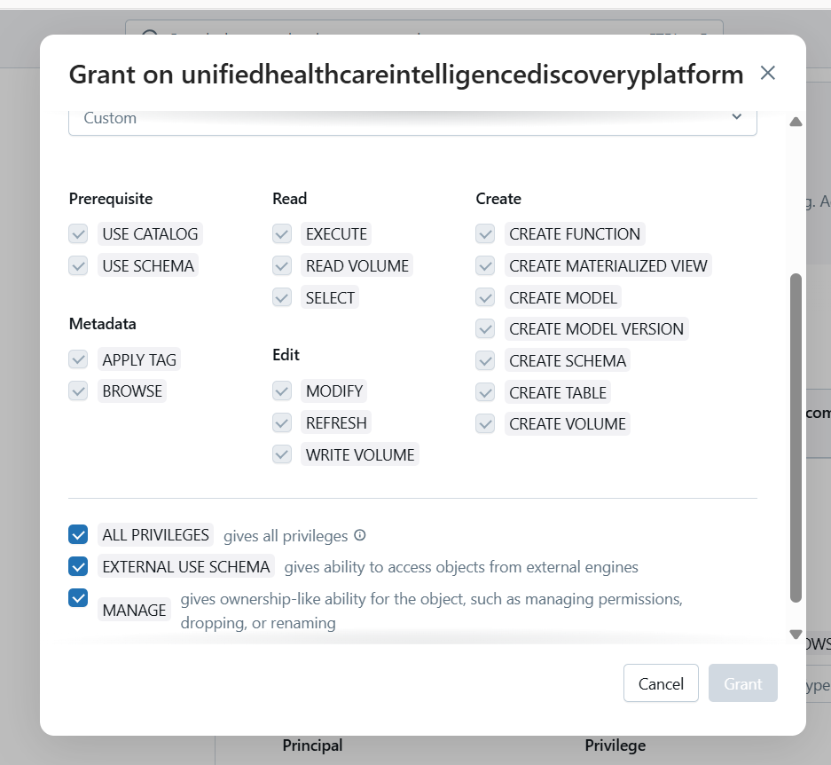
Also, tags and descriptions can be added in the metadata management for better data searching in future.
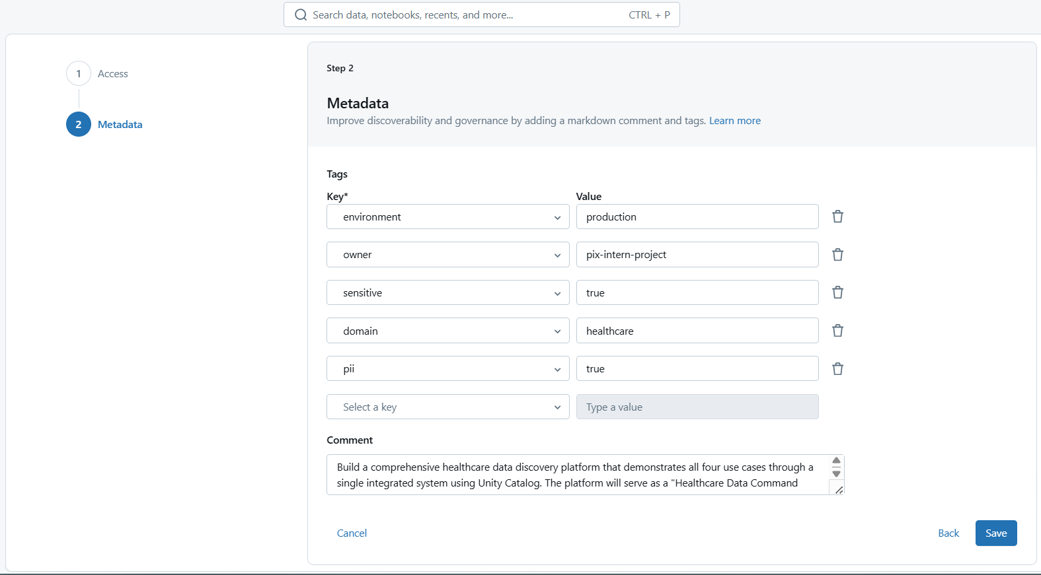
The catalog contains four schemas, each representing a major domain of healthcare data.
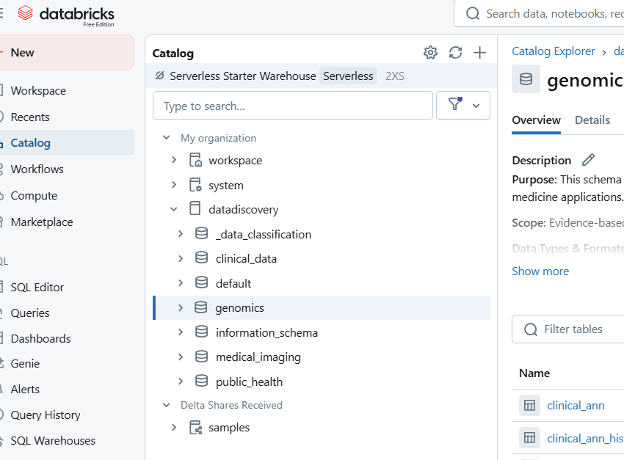

Below are the schemas and the datasets associated with each:
1. Schema: clinical_data
Dataset: Synthea Synthetic Health Records
- Description: This dataset contains synthetic electronic health record (EHR) data generated by Synthea, a synthetic patient population generator. It includes realistic but not real patient data for testing and research purposes.
- Files Included (CSV): allergies.csv, careplans.csv, claims.csv, conditions.csv, devices.csv, and others.

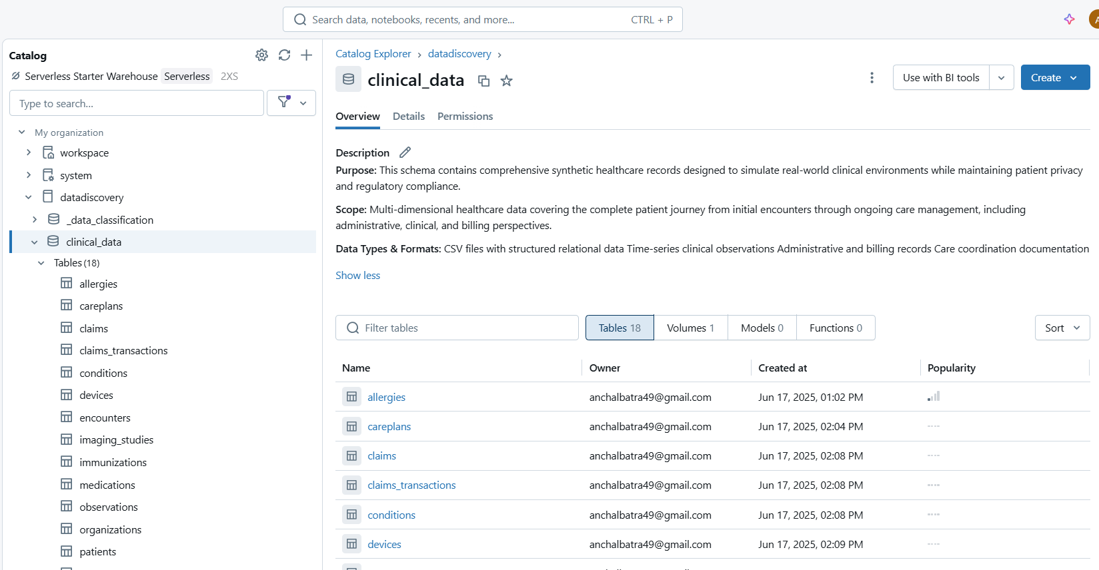

2. Schema: genomics
Dataset: PharmGKB Clinical Annotations
- Description: This dataset includes curated clinical annotations from the Pharmacogenomics Knowledgebase (PharmGKB), detailing evidence-based associations between genetic variants and drug responses.
- Files Included: clinical_ann.tsv, clinical_ann_metadata.tsv, etc.
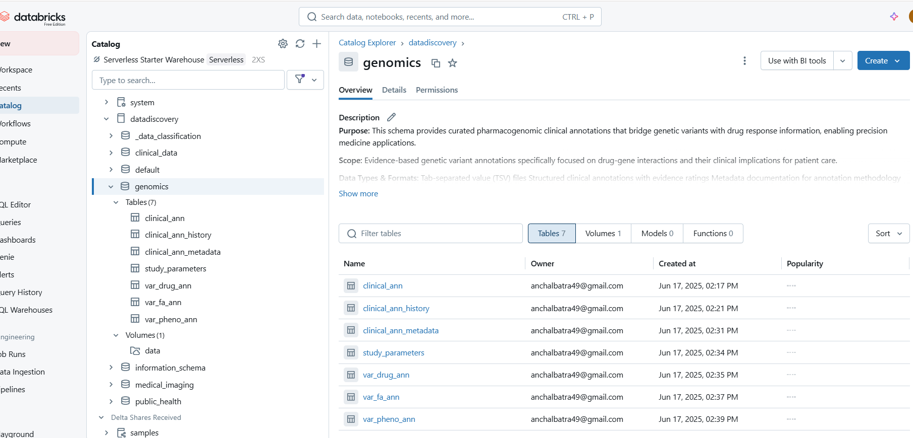

3. Schema: medical_imaging
Dataset: COVID-19 Chest X-ray Imaging
- Description: A medical imaging dataset consisting of chest X-ray scans of COVID-19 patients. It supports image-based diagnostic model development using machine learning or deep learning techniques.
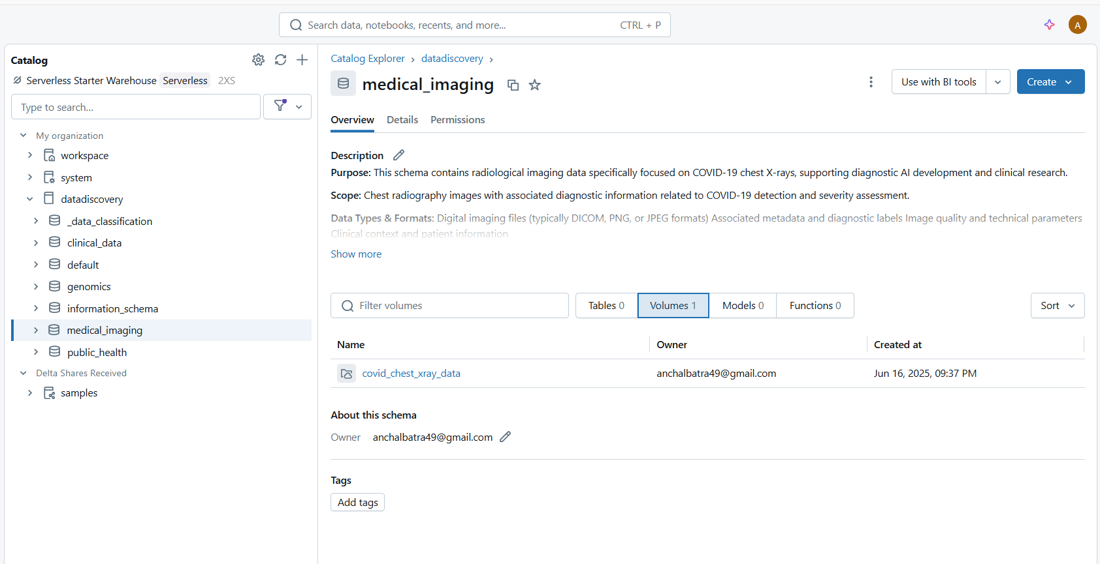

4. Schema: public_health
Dataset: COVID-19 Data Repository by CSSE at Johns Hopkins University
- Description: A widely recognized time-series dataset that tracks the global spread of COVID-19. It includes confirmed cases, deaths, and recoveries by date and geography.
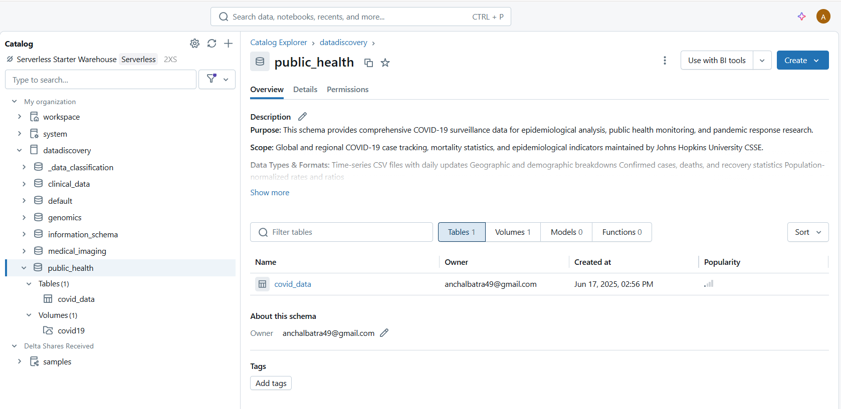

2.3.2 Data Ingestion, Table Creation, and Metadata Tagging
After establishing the catalog structure, the following steps were undertaken to fully operationalize the dataDiscovery catalog for efficient healthcare data discovery:
Schema Setup and Data Ingestion
Four domain-specific schemas were created within the catalog:
- clinical_data
- genomics
- medical_imaging
- public_health
Each schema corresponds to a specific area of healthcare research and practice. Relevant datasets were uploaded into Volumes associated with each schema. These datasets include structured health records, genomic annotations, medical imaging data, and public health statistics.
Table Creation from Ingested Data
For each dataset stored in the Volumes, structured tables were created using Unity Catalog. These tables represent the underlying data in a queryable format. The schema was inferred or explicitly defined depending on the structure and complexity of the source data files (e.g., .csv, .tsv, or image metadata).
Examples:
- clinical_data.allergies, clinical_data.conditions, clinical_data.devices, etc.
- genomics.clinical_ann, genomics.clinical_ann_metadata
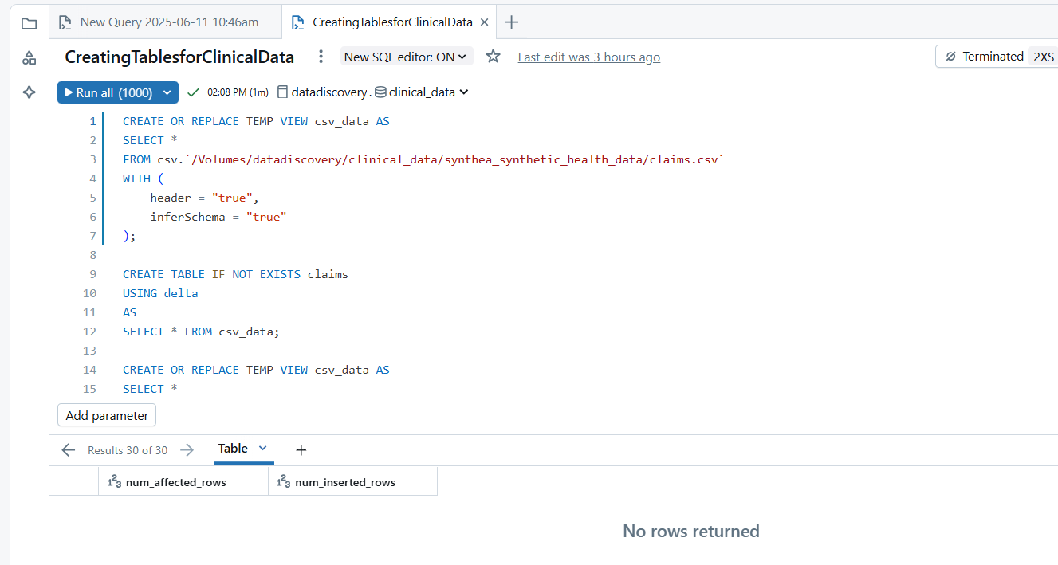
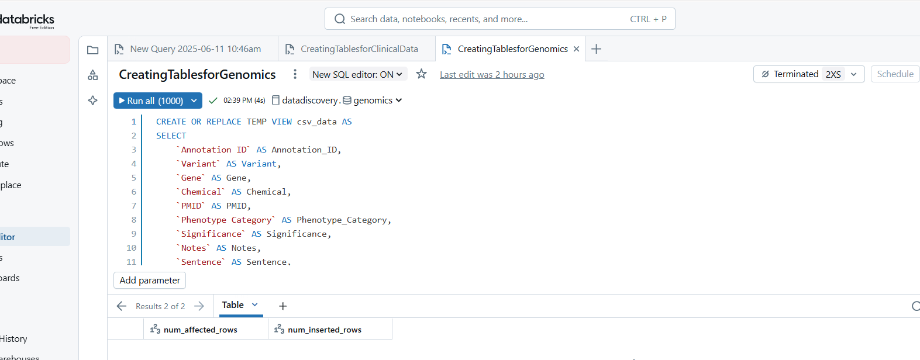
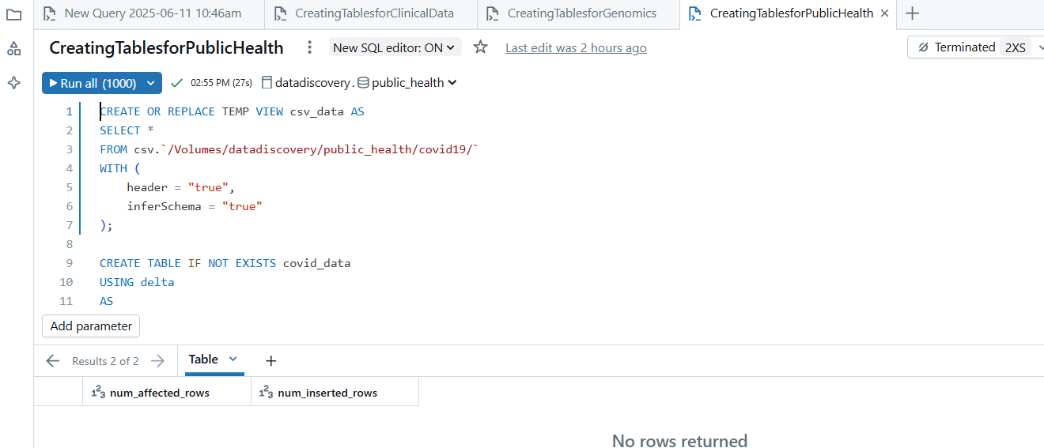

2.3.3 Metadata Enrichment: Descriptions and Tags
Each table created was enriched with:
- Detailed Descriptions: Providing an overview of the dataset contents, structure, and relevance to healthcare research.
- Metadata Tags: Tags were assigned to each table to facilitate search, discovery, and governance.
This metadata tagging and documentation enhance usability and ensure that stakeholders across the organization can locate and understand the datasets effectively.
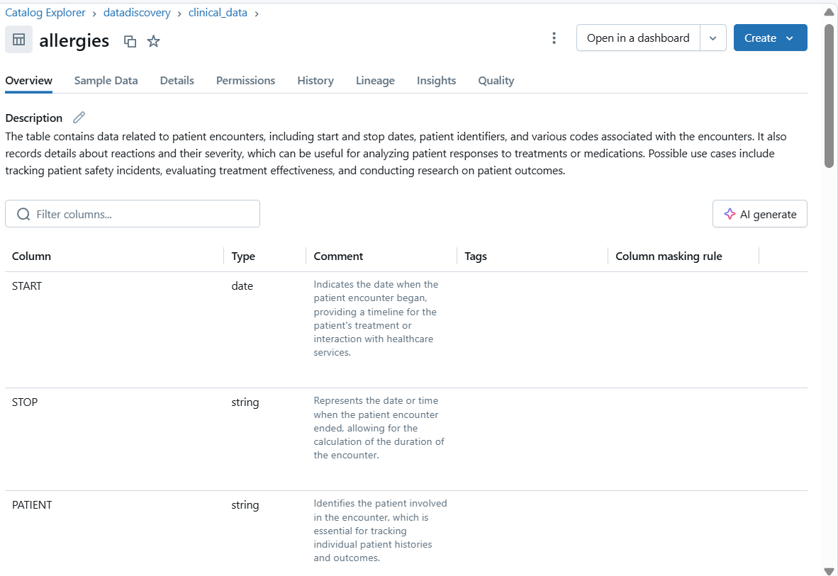

2.3.4 Catalog Hierarchy
Catalog: dataDiscovery
│
├── Schema: clinical_data
│ ├── Volume: /Volumes/dataDiscovery/clinical_data/
│ │ ├── allergies.csv
│ │ ├── careplans.csv
│ │ ├── claims.csv
│ │ ├── conditions.csv
│ │ └── devices.csv
│ ├── Table: allergies
│ ├── Table: careplans
│ ├── Table: claims
│ ├── Table: conditions
│ └── Table: devices
│
├── Schema: genomics
│ ├── Volume: /Volumes/dataDiscovery/genomics/
│ │ ├── clinical_ann.tsv
│ │ └── clinical_ann_metadata.tsv
│ ├── Table: clinical_ann
│ └── Table: clinical_ann_metadata
│
├── Schema: medical_imaging
│ ├── Volume: /Volumes/dataDiscovery/medical_imaging/
│ │ ├── /positive/
│ │ │ └── [X-ray images...]
│ │ └── /negative/
│ │ └── [X-ray images...]
│
└── Schema: public_health
├── Volume: /Volumes/dataDiscovery/public_health/
│ └── 01-01-2021.csv
│ └── 02-01-2021.csv
│ └── 03-01-2021.csv
└── Table: covid19

2.3.5 Data Discovery Demonstration
Demo 1: Metadata Tagging and Searching
Objective: Demonstrate how to tag a dataset and search it using Unity Catalog’s search capabilities.
Step 1. Open Unity Catalog: Navigate to the Unity Catalog in your Databricks workspace.
Step 2. Select the Dataset: Choose the dataset you want to tag.
Step 3. Scroll down and click on Add tags.
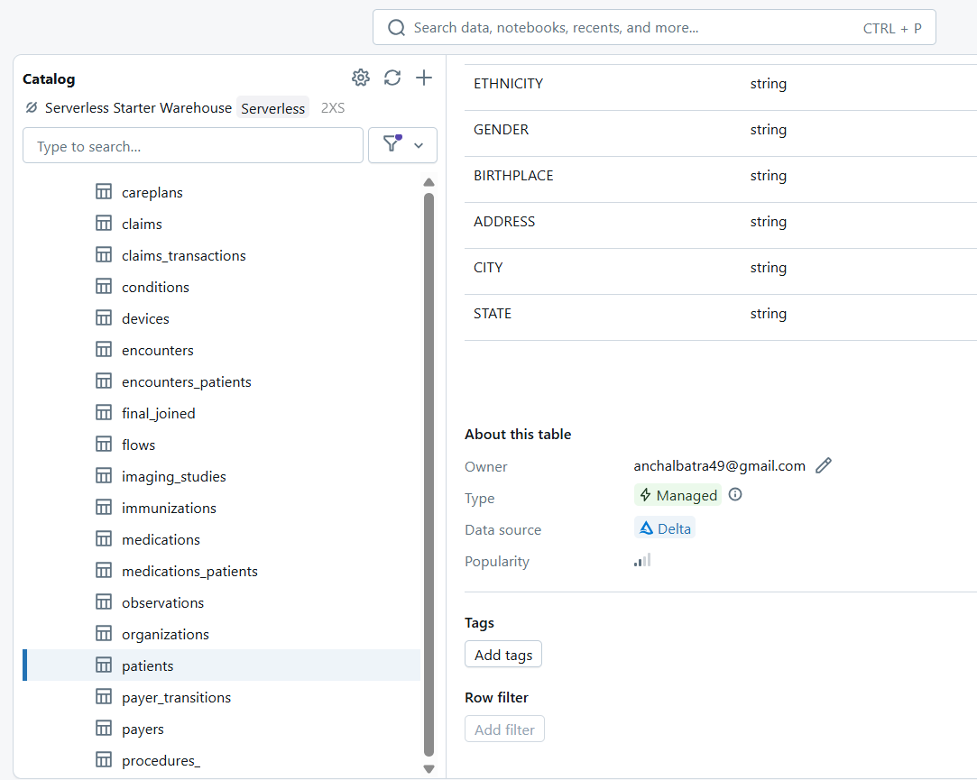
Step 4. Add desired tags based on the type of data and click on Save button.
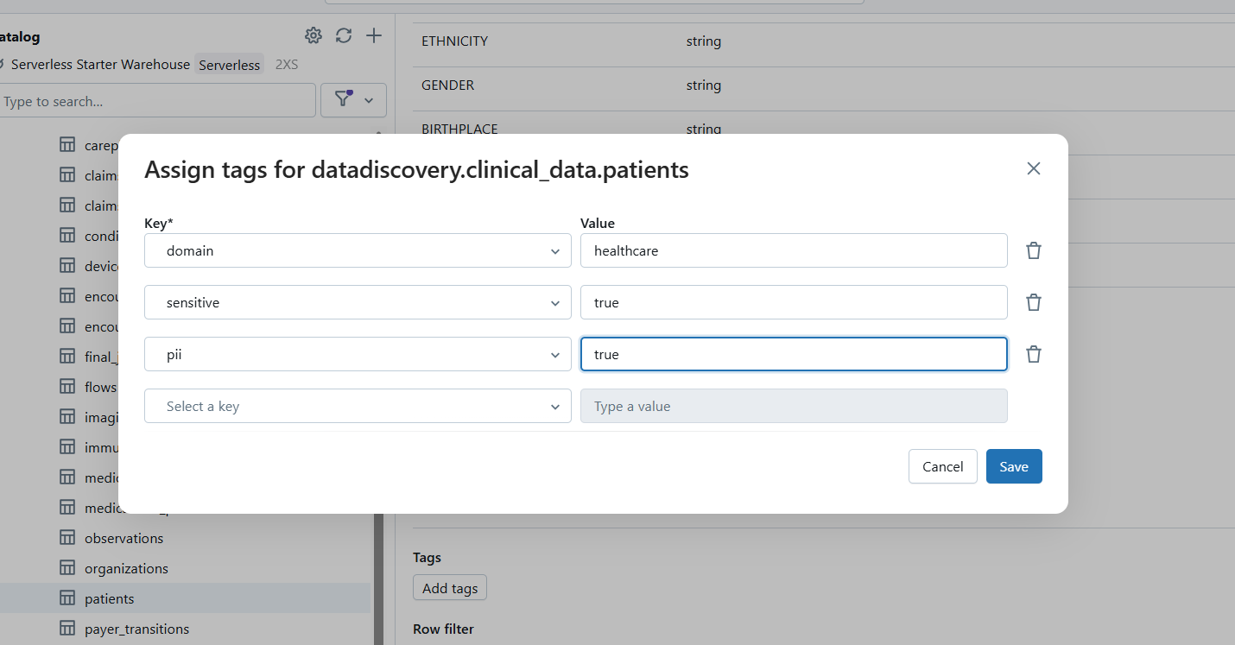

Optional: Add tags using SQL queries on tables.
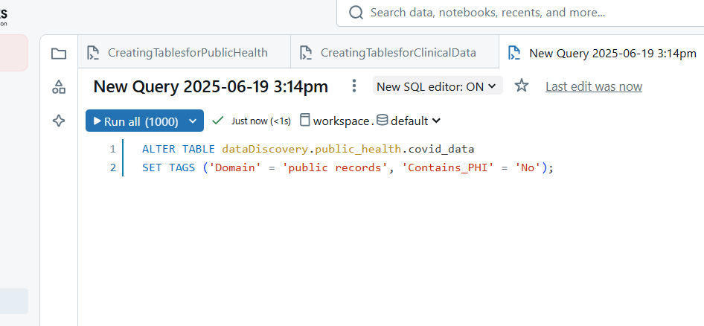

Step 5: Search for tables tagged with “public records”.
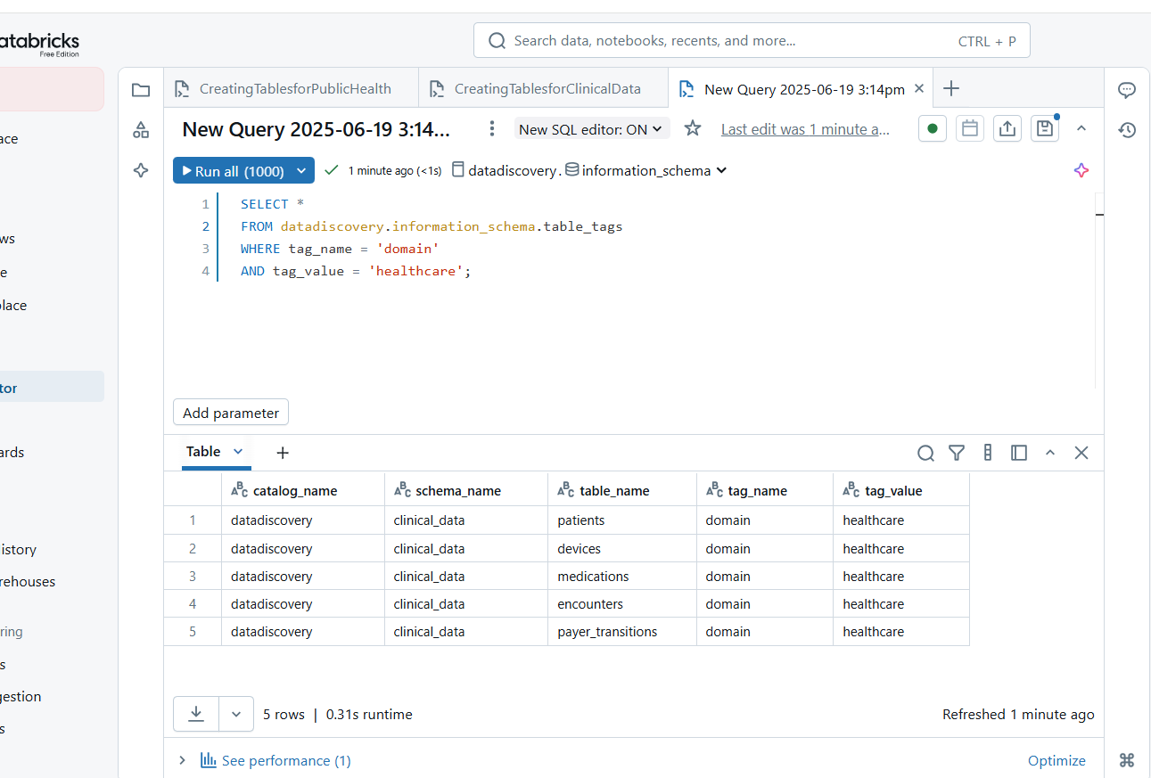
This demo shows how metadata tags can be used for better classification and how researchers can filter only the required domain-specific data with just a single query. Using Unity Catalog’s search capabilities, it was very easy to add tags and then search data by using keywords.
Demo 2: Natural Language Search for Healthcare Terms (via UI)
Objective: Search for tables or data assets using the search UI of databricks environment to generate results.
Step 1. Go to the Data Explorer in the Databricks workspace.
Step 2. Type “COVID patient conditions” or “allergies with PHI” in the search bar.
Step 3. Unity Catalog fetches results matching the description, using NLP and metadata tags.
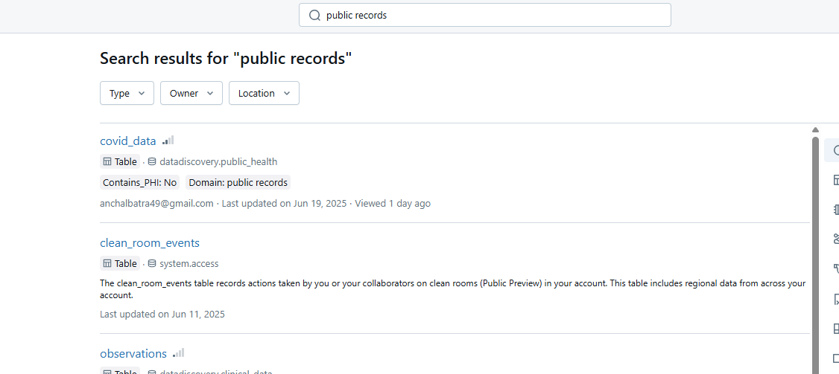
Even without knowing exact table names, a clinical user can use simple queries like ‘patient diagnosis’ or ‘X-ray COVID’ to find relevant datasets quickly.
Demo 3: Tag-Based Access Control Simulation
Objective: Demonstrate how sensitive data (like PHI) can be restricted based on tags.
Step 1: Create a user group for research analysts and add a user into this group. For now, let us add another mail id of the same user for the demo.
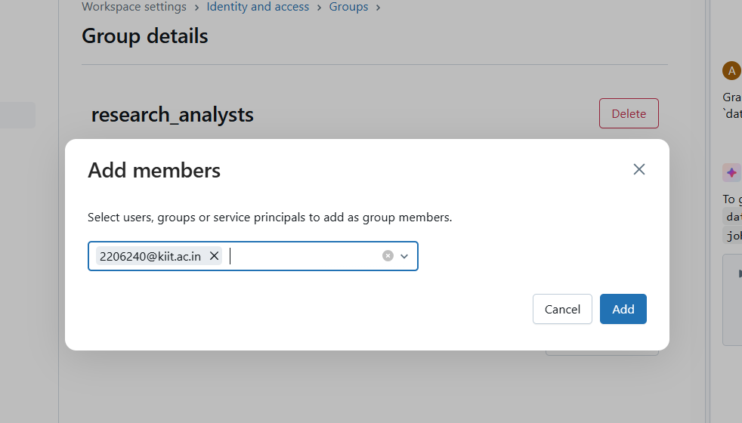
Step 2: Grant table access conditionally using sql queries or manual access management.
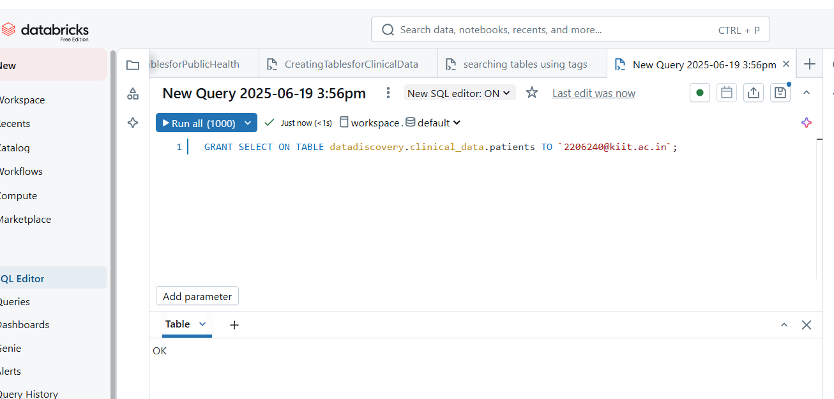Step 3: Simulate restricted access
Try querying a tagged table from a restricted user account.

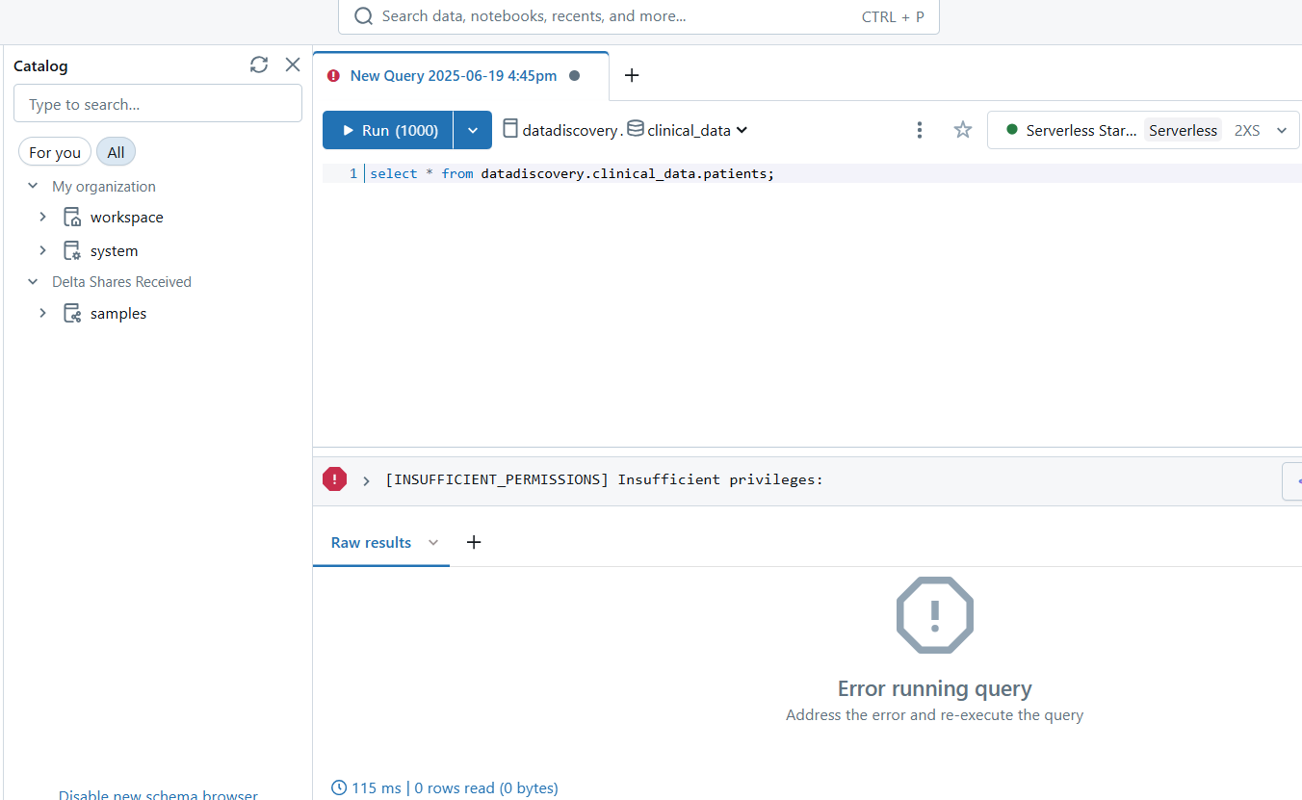

If this user tries to access another table which does not have PHI and is granted access to that, then the result will show data present in that table.
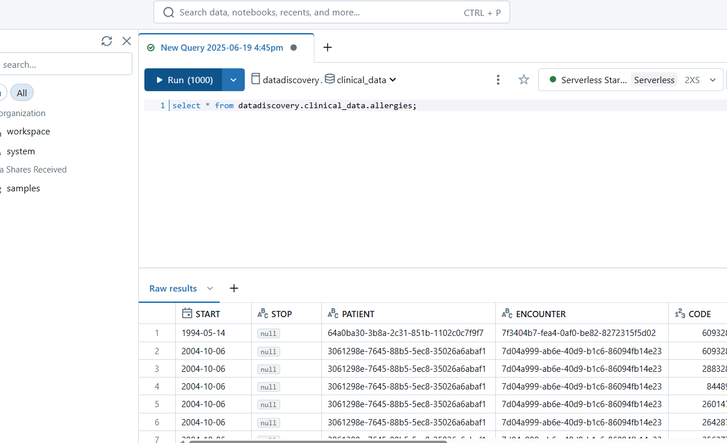
This demonstrates how tagged PHI data can be restricted without hardcoding, using a policy-driven approach.
Demo 4: Discovering Unstructured Data (X-rays)
Objective: Search and preview image-based datasets from the medical_imaging schema.
Step 1. Navigate to /Volumes/dataDiscovery/medical_imaging/positive/ in Data Explorer.
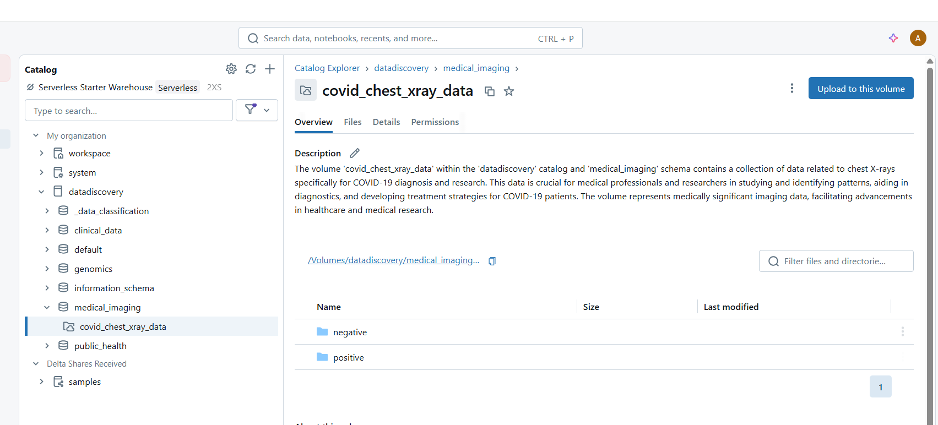
Step 2. Preview image metadata or attach labels to each scan based on COVID status.
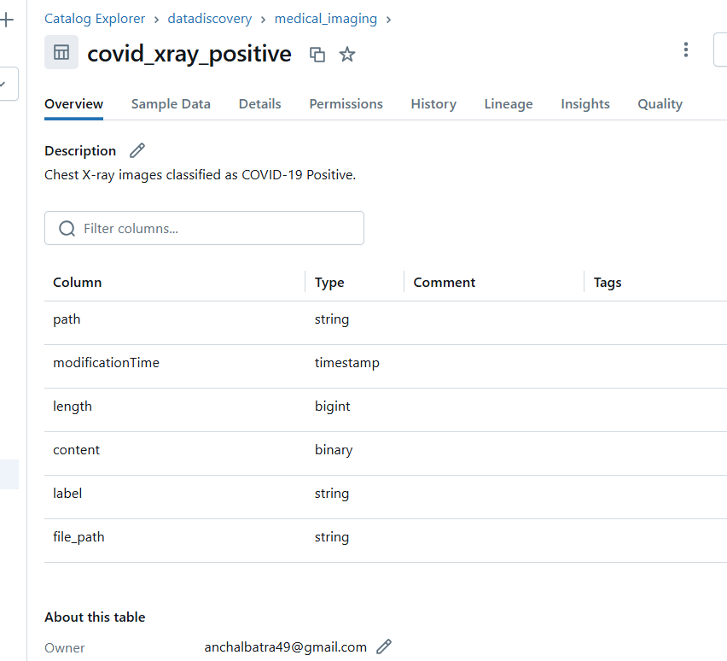
Result: Radiologists or ML engineers can now use metadata search to locate image sources quickly.
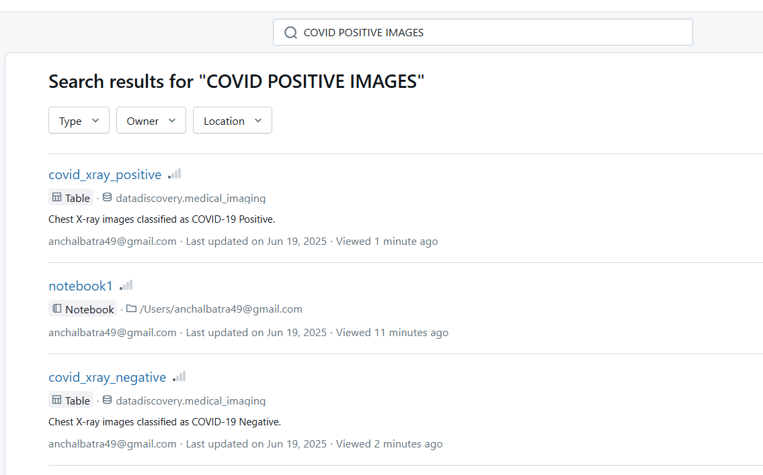

2.4 Advanced Data Lineage Capabilities

2.4.1 Feature Overview
Data Lineage is a feature of Unity Catalog which is used to describe the transformations and refinements of data from the time it is sourced to the present. Lineage provides a comprehensive view of all the metadata and moves through the complete lifecycle of data. It comprises of all the important information including the source of dataset, who created it and when, what other datasets were used to refine it, and many other attributes and events. Lineage is supported for all languages and it goes from table level to column level. All data assets including tables, volumes, notebooks, jobs, dashboards, etc. can be tracked to understand the transformations performed in the past.
With data lineage, the performance of an organization is significantly improved as it fosters collaboration by offering a clear understanding of how data is utilized by different people or teams. Issues and errors in data quality can be identified faster by tracking lineage as it highlights events or processes that might be responsible for introducing them. Also, it provides a transparent record of changes performed, access control, and data movements which is facilitates compliance with regulatory standards.

2.4.2 Lineage Tracking Mechanisms
Unity Catalog offers various lineage tracking mechanisms to capture the flow of data from its source, through transformations, and finally to the destination. Some of the key mechanisms are listed below:
- Automated Lineage Capture: Unity Catalog automatically captures the lifecycle of data and all queries at runtime in the databricks environment. It includes tracking data transformation from granular level to the column level.
- Lineage Visualization: For each transformation or flow of data, lineage can be visualized in the form of lineage graphs. These visualizations are available using the Databricks UI or can be accessed programmatically through Databricks REST API.
- System Tables: Unity Catalog create system tables like system.access.table_lineage to store and retrieve the detailed lineage information, which can be used to track changes.
- Impact Analysis: Data goes through numerous changes and these changes could have affected the downstream sources from where it was generated. To analyse the impact of each transformation, impact analysis can be used to assess the severity of impact, from the perspective of risk management.

2.4.3 Lineage Tracking Requirements
To capture and view data lineage in Unity Catalog, there are certain requirements that need to be satisfied.
To capture:
- Tables must be registered in a metastore configured with Unity Catalog.
- Spark Dataframe or Databricks SQL interfaces must be used to query data in notebooks or SQL query editor.
To view:
- For tables or views, the parent catalog must be accessible from the workspace. Also, at least BROWSE privilege should be granted on the table or view.
- For notebooks, jobs, or dashboards, permissions must be assigned as defined in the access control on these objects to view lineage graphs.
Certain compute and networking requirements must also be satisfied to avoid any connectivity issues if you want to view lineage of streaming between Delta Tables.

2.5 Ensuring Data Integrity with Unity Catalog

2.5.1 Automated Lineage Tracking for patient data
Unity Catalog automatically captures lineage information across various levels, which ranges from table level, column level, and even field level for healthcare data. In healthcare organizations, patient data or public records transition from one form to another by going through numerous processes. From capturing data from EHRs to loading it to lakes or warehouses, Unity catalog keeps track of every transformation precisely, including aggregation or fragmentation of different datasets, join operations, and cleaning of data. This detailed tracking helps healthcare organizations to go back to original forms of datasets in case of potential data issues. It also helps to verify accuracy and efficiency of data. The platform’s ability to automatically track changes reduces huge quantity of manual effort required for monitoring excess amounts of data in healthcare settings. In traditional database management systems, a lot of time and effort is required to document data flows, while providing real-time visualizations, which is saved by Databricks’ Unity Catalog.

2.5.2 Data Quality Validation through Lineage
The visibility of transformation of data in Unity Catalog is crucial for identifying and rectifying inconsistencies in data. Capturing and visualizing the entire renovation processes helps the healthcare providers to trace lineage of patient records while keeping a check on its quality.
Consider a scenario where a healthcare organization collects patient data from various sources, including EHRs, imaging systems and lab results. If an error is found in lab results, the organization can trace back to the data sources which generate this report, to check the foundation of fault, whether it was during the data entry, processing, or integration. The organization can also check for completeness, accuracy and consistency of data as validation steps are captured in lineage information, making it easy to verify that the data quality standards are met.
When data quality issues are identified, lineage information can also help to understand the intensity of impact and how to formulate remediation strategies. A transparent view of data handling practices is provided by Unity Catalog while tracking modifications.

2.5.3 Integration with Healthcare Standards
The ability of Unity Catalog to support integration with various healthcare standards ensures that the data transformations are accurately documented and auditable. In a sector where maintaining data integrity, compliance, and interoperability are a crucial part of operational efficiency, Unity Catalog enhances the performance of the organizations by accommodating healthcare-specific formats and services.
Unity Catalog provisions several healthcare data standards and formats, containing:
- HL7 FHIR (Fast Healthcare Interoperability Resources)
- DICOM (Digital Imaging and Communications in Medicine)
- Clinical terminology systems like SNOMED CT (Systematized Nomenclature of Medicine - Clinical Terms) and ICD-10 (International Classification of Diseases, 10th Revision)
These standards are vital for ensuring interoperability and consistency in healthcare data.

2.6 Compliance and Auditing using Unity Catalog

2.6.1 HIPAA Compliance Through Audit Trails
Unity Catalog's data lineage features directly facilitate HIPAA compliance by offering thorough audit trails that monitor who accessed patient data, the timing of access, the transformations applied, and the subsequent usage of the data. This level of granularity is vital for fulfilling HIPAA's administrative safeguards requirements, which necessitate that covered entities establish procedures to ensure that access to electronic protected health information (ePHI) is adequately controlled and monitored.
The platform automatically records all data access and transformation activities, generating an immutable audit trail that can be utilized to demonstrate compliance during regulatory inspections. This encompasses tracking data lineage across batch processing jobs, real-time streaming applications, and interactive analytics sessions, guaranteeing that no access to patient data remains unrecorded.

2.6.2 Automated Compliance Reporting
Unity Catalog simplifies the compliance reporting process by offering pre-built reporting functionalities that utilize lineage information to produce comprehensive compliance reports. These reports can illustrate data governance practices, demonstrate how patient data is safeguarded throughout its lifecycle, and provide proof of appropriate access controls and data handling procedures.
Healthcare organizations can set up automated reports that monitor key compliance metrics, such as data retention periods, access patterns for sensitive patient information, and adherence to data minimization principles. These reports can be generated on-demand for regulatory inspections or scheduled to ensure continuous compliance monitoring.

2.6.3 Risk Assessment and Impact Analysis
In the event of potential security incidents or data breaches, Unity Catalog's lineage information allows for swift impact assessment by indicating precisely which patient records may have been affected and which downstream systems or processes may have been compromised. This capability is essential for fulfilling HIPAA's requirements.

2.7 Unity Catalog’s Data Lineage Architecture
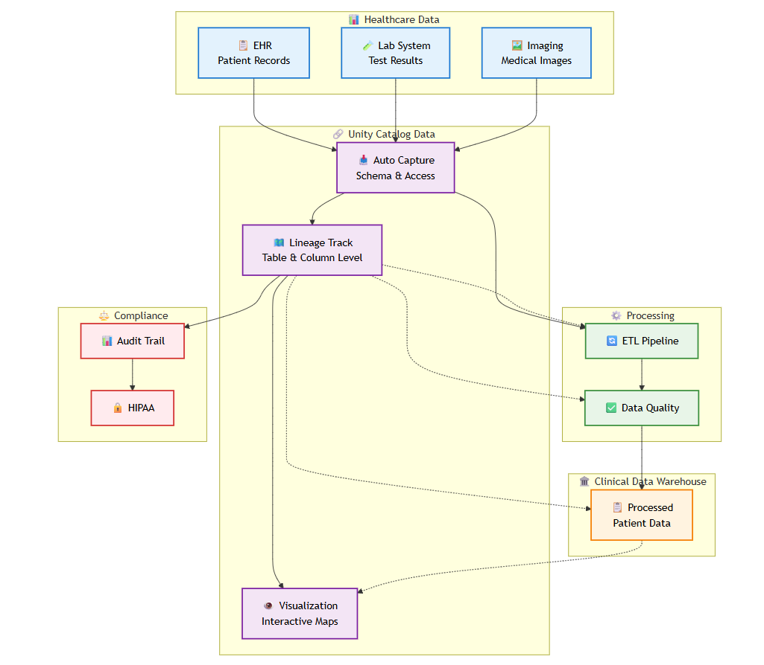
The diagram represents how data lineage capabilities function in Unity Catalog within the healthcare environment. It clearly demonstrates the broad tracking of patient data collected from multiple sources through various processing stages to final consumption.
At the top level, data ingestion layer is represented where there are three healthcare sources that feed data into the system. These sources are comprised of Electronic Health Records (EHRs) for patient information, Laboratory Information Management Systems (LIMS) for lab test results, and Picture Archiving Communication Systems (PACS) for management of medical imaging data including X-rays, CT scans, MRIs, and other reports.
The central component of the architecture represents Unity Catalog’s core lineage capabilities. These capabilities work through three main components- automatic lineage capture, lineage tracking, and visualization. Automatic capture continuously monitors and records metadata and user interactions, eliminating the need of manual effort. Lineage tracking help to understand how clinical metrics are calculated, what logic was applied during transformation, while taking into consideration the data accuracy. Visualization is important to explore relationships visually.
Compliance and auditing at the left shows how lineage information in Unity Catalog supports regulatory requirements. It is essential to maintain complete records of access control and ensure that data handling meets the needs of data privacy and security.
Data quality validation and ETL processes to transform data into structured format is also tracked by lineage layer. This ensures that the processed data is in a standardized format and is modified according to healthcare needs and requirements.

2.8 Implementation Use Cases: Lineage

2.8.1 View Table Lineage
Step 1: Go to the Catalog and search for the table for which you have to track lineage.
Step 2: Click on Lineage on top right. The lineage panel appears and displays related tables.
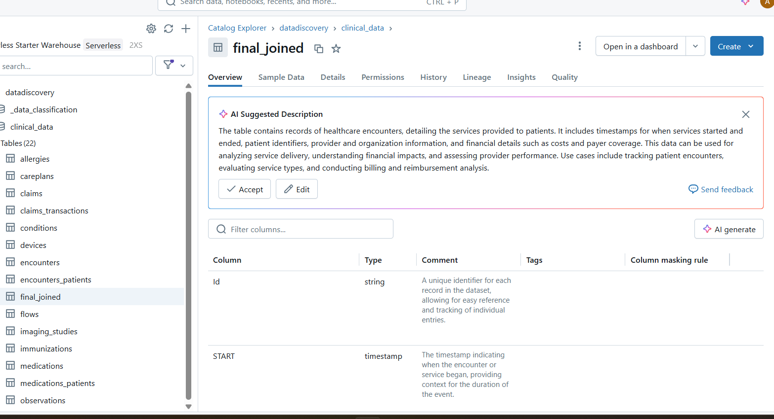

The lineage panel appears and displays related tables. It represents the data transformations performed on the table in past.
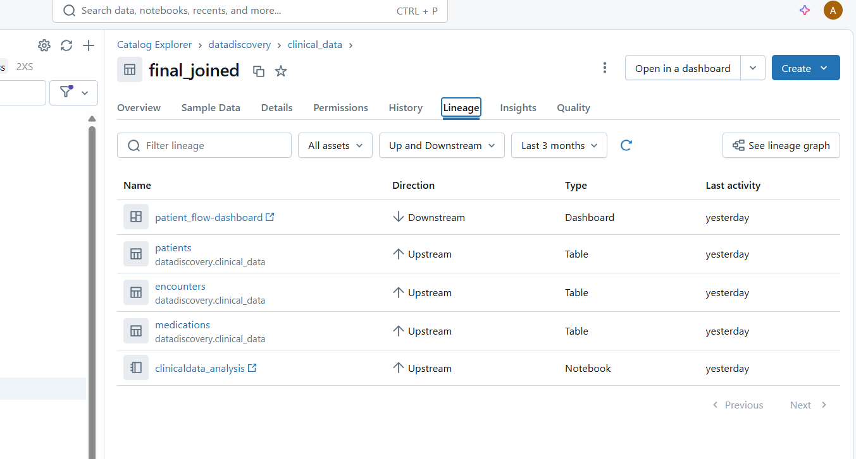
Step 3: To view an interactive graph of the data lineage, click See Lineage Graph.
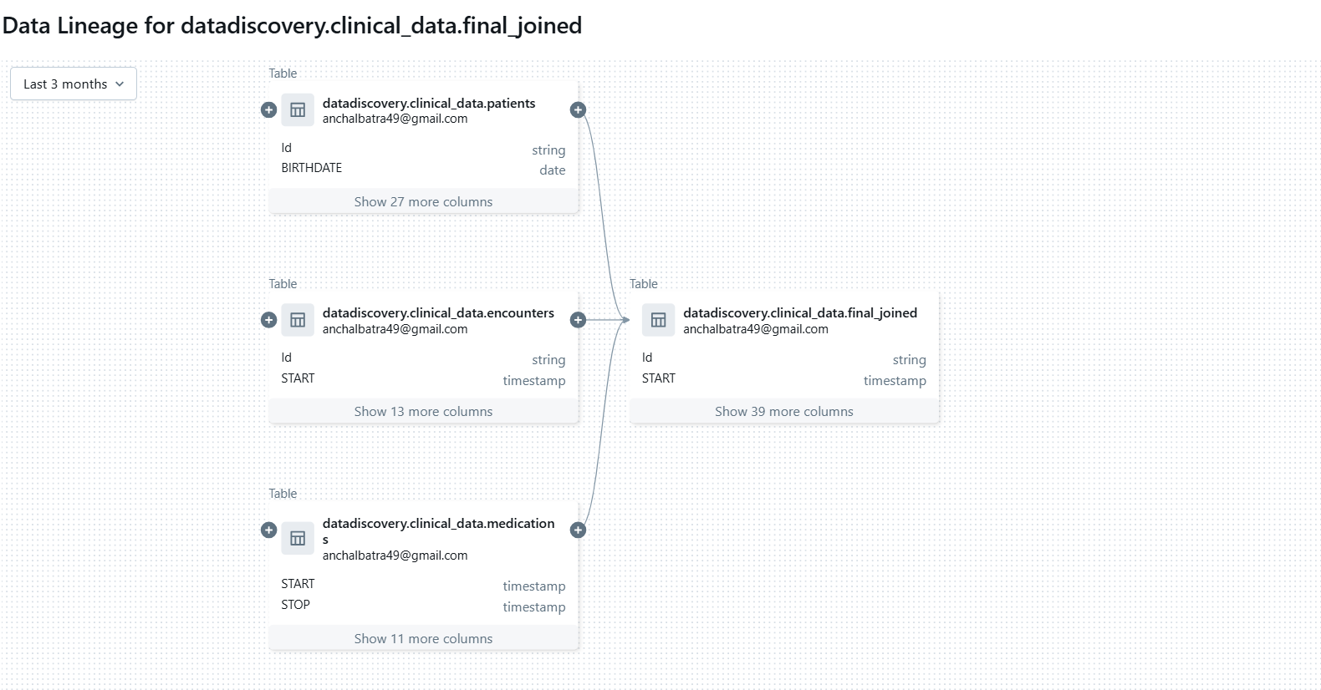
By default, one level is displayed in the graph. Click the plus icon on a node to reveal more connections if they are available.
On clicking the connection nodes, the Lineage Connection Panel will be opened. It shows details about the connection, including source and target tables, notebooks, and jobs.
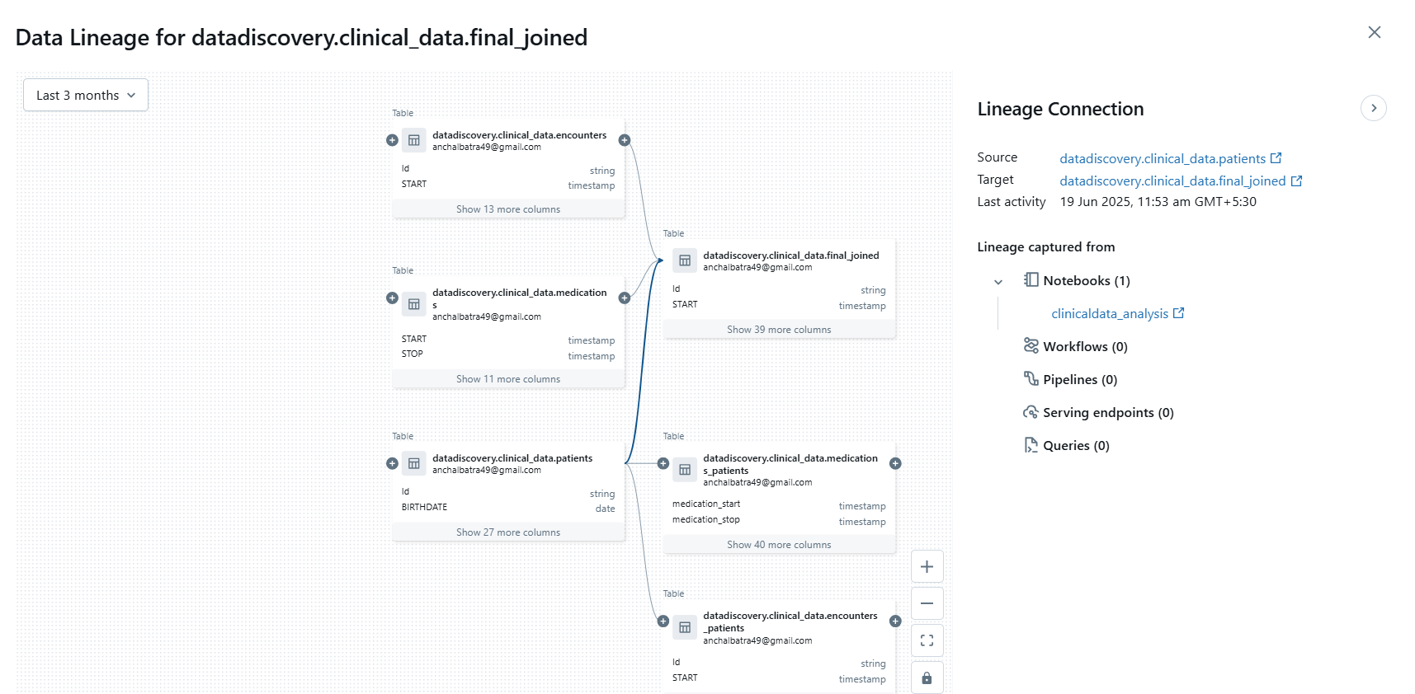

2.8.2 View Column-Level Lineage
To view column-level lineage, click a column in the graph to show links to related columns. For example, clicking on Dispenses column show the relationships between tables as follows:
